**Exercise Questions**

1. Write a MongoDB query to display all the documents in the collection restaurants. 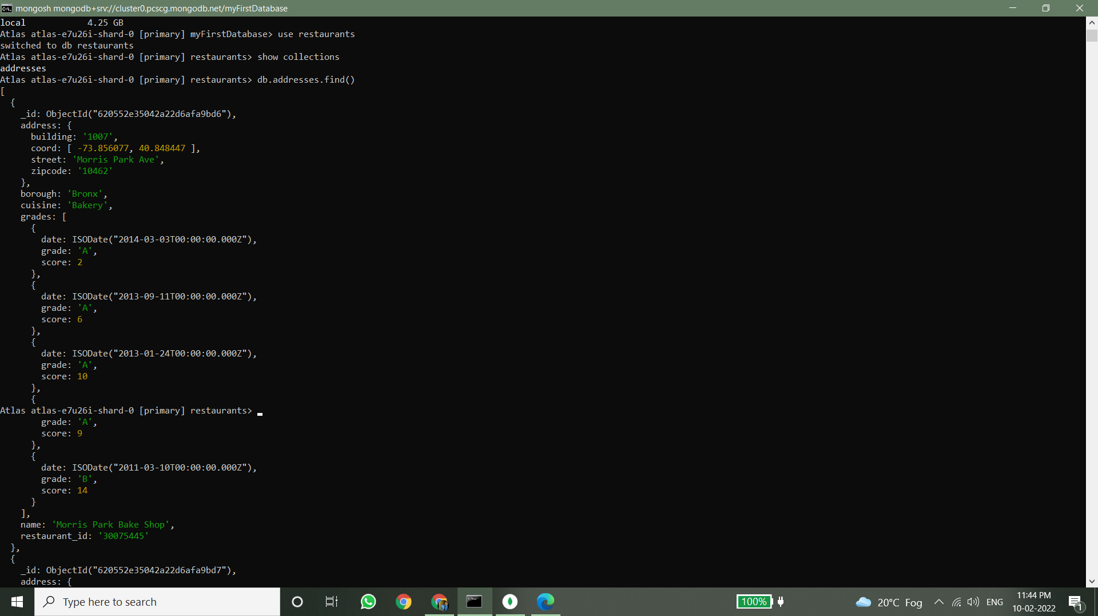

2. Write a MongoDB query to display the fields restaurant_id, name, borough and cuisine for all the documents in the collection restaurant.

3. Write a MongoDB query to display the fields restaurant_id, name, borough and cuisine, but exclude the field _id for all the documents in the collection restaurant.

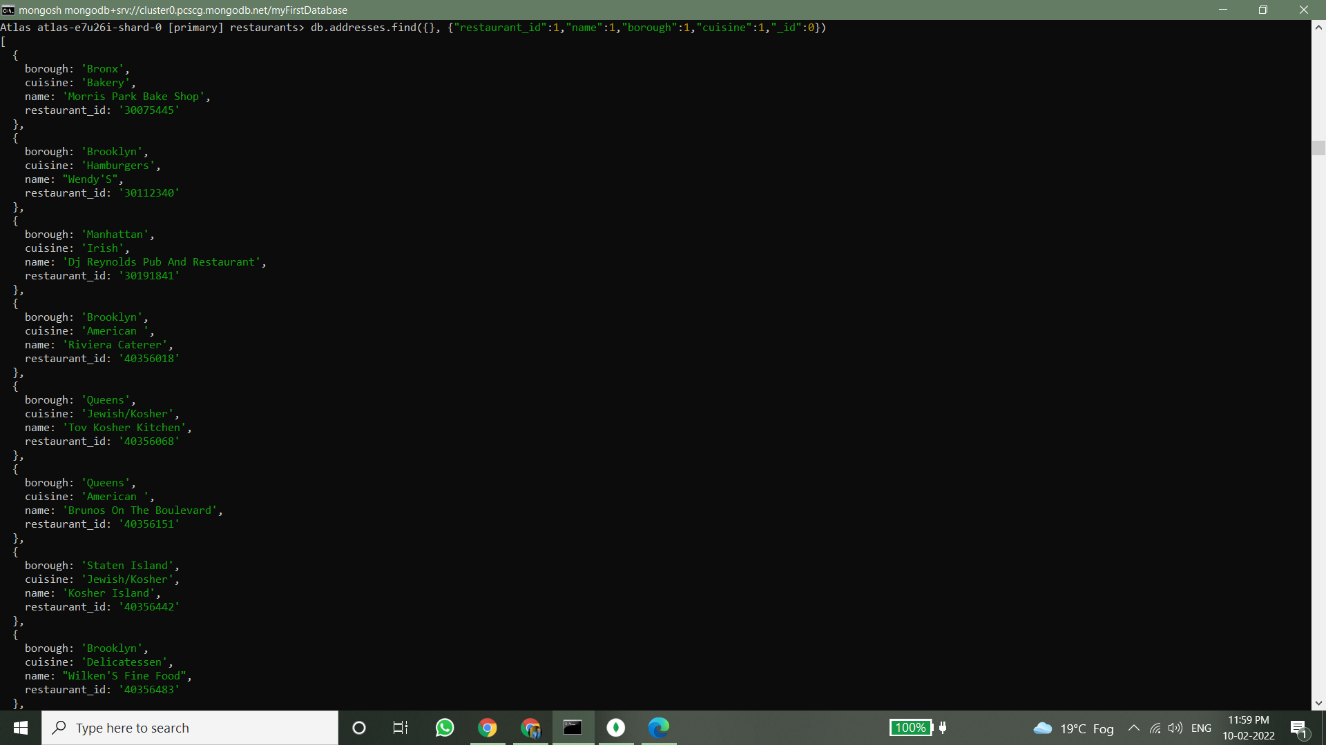

4. Write a MongoDB query to display the fields restaurant_id, name, borough and zip code, but exclude the field _id for all the documents in the collection restaurant. 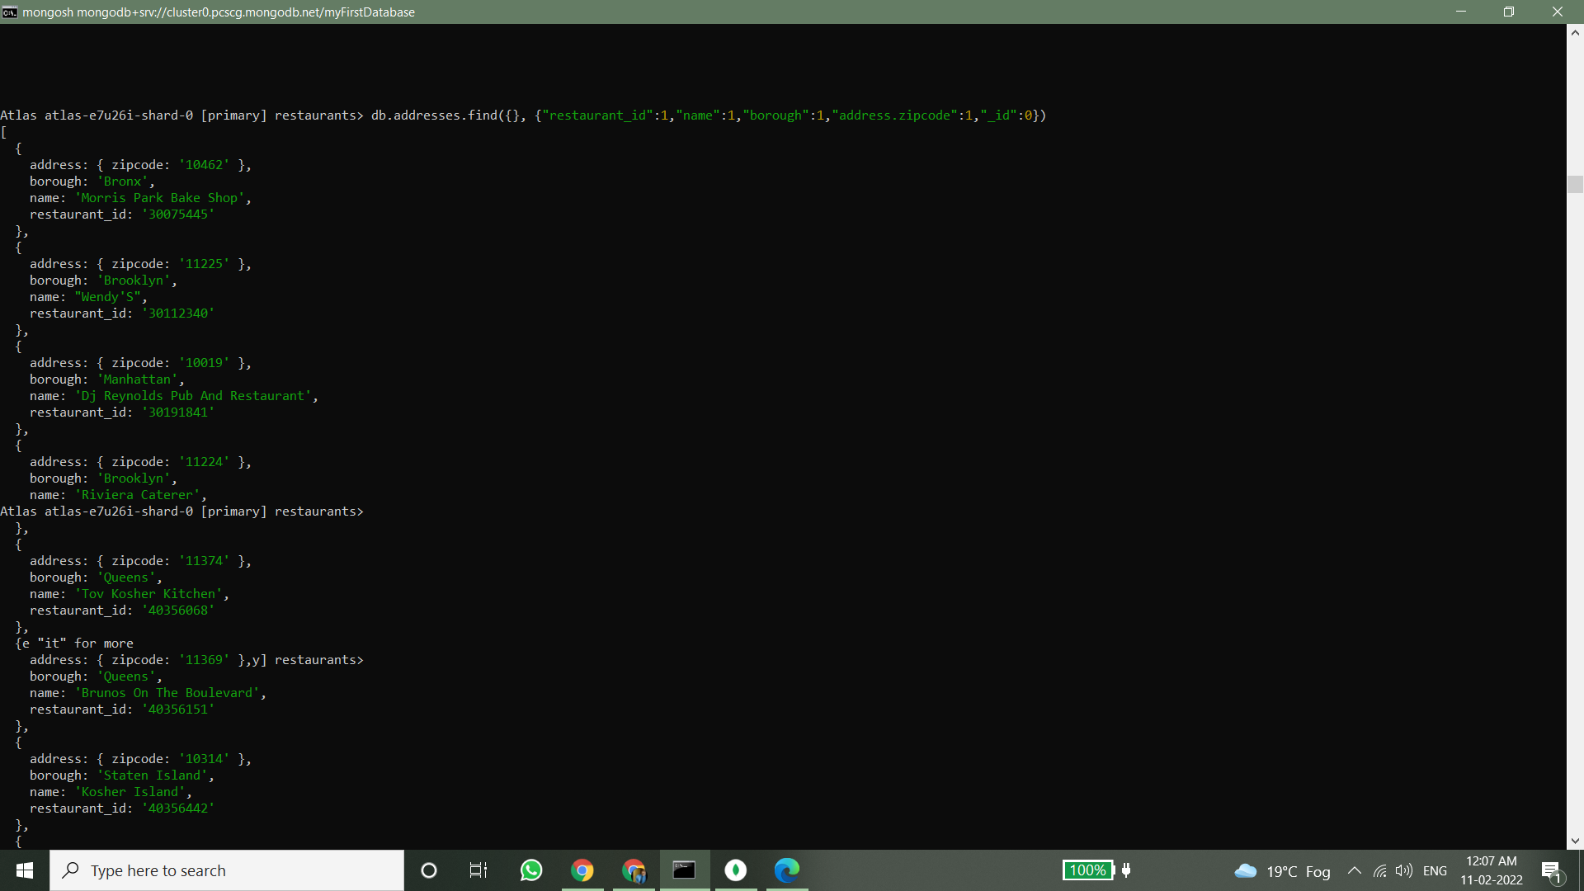

5. Write a MongoDB query to display the first 5 restaurant which is in the borough Bronx. 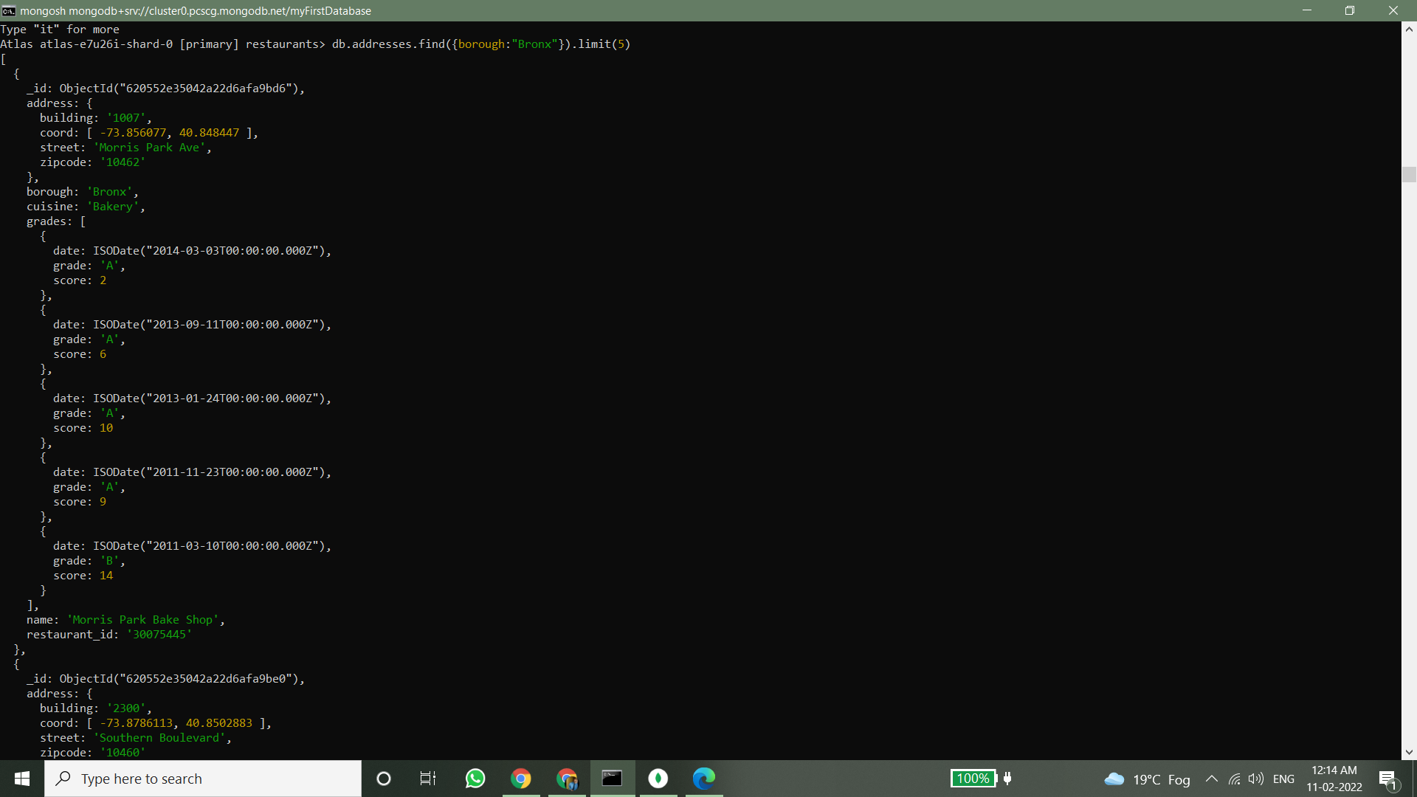

6. Write a MongoDB query to display all the restaurant which is in the borough Bronx. 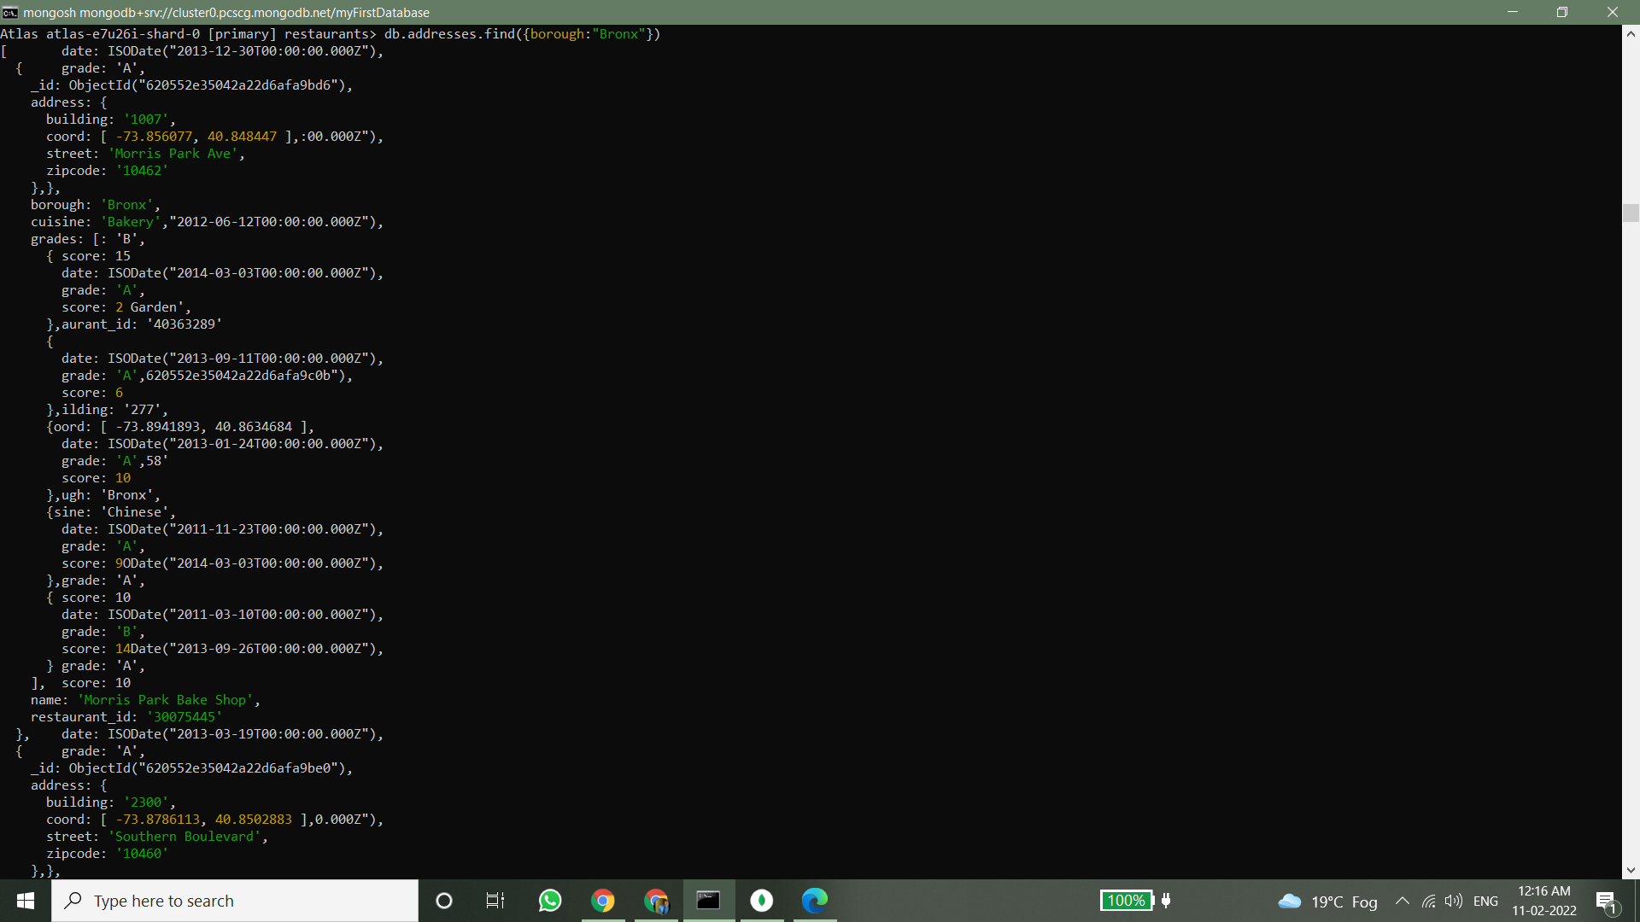

7. Write a MongoDB query to display the next 5 restaurants after skipping first 5 which are in the borough Bronx. 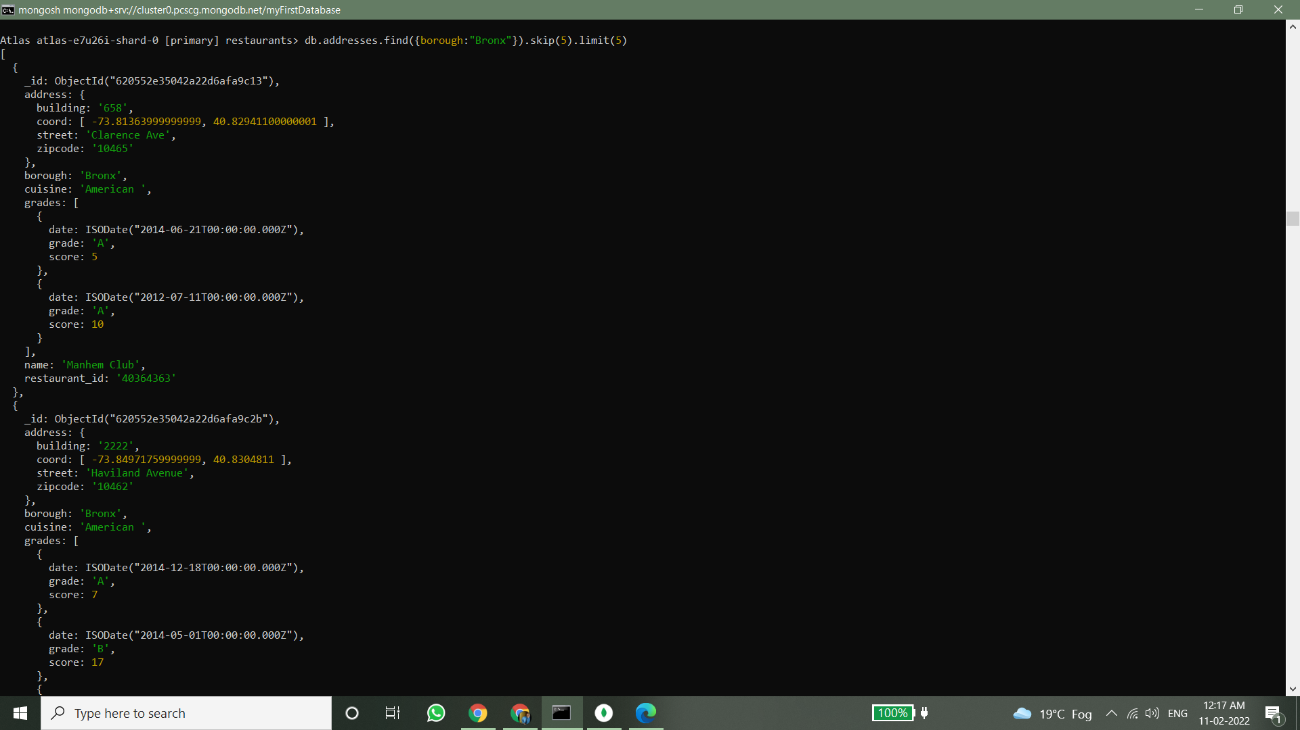

8. Write a MongoDB query to find the restaurants who achieved a score more than 90. 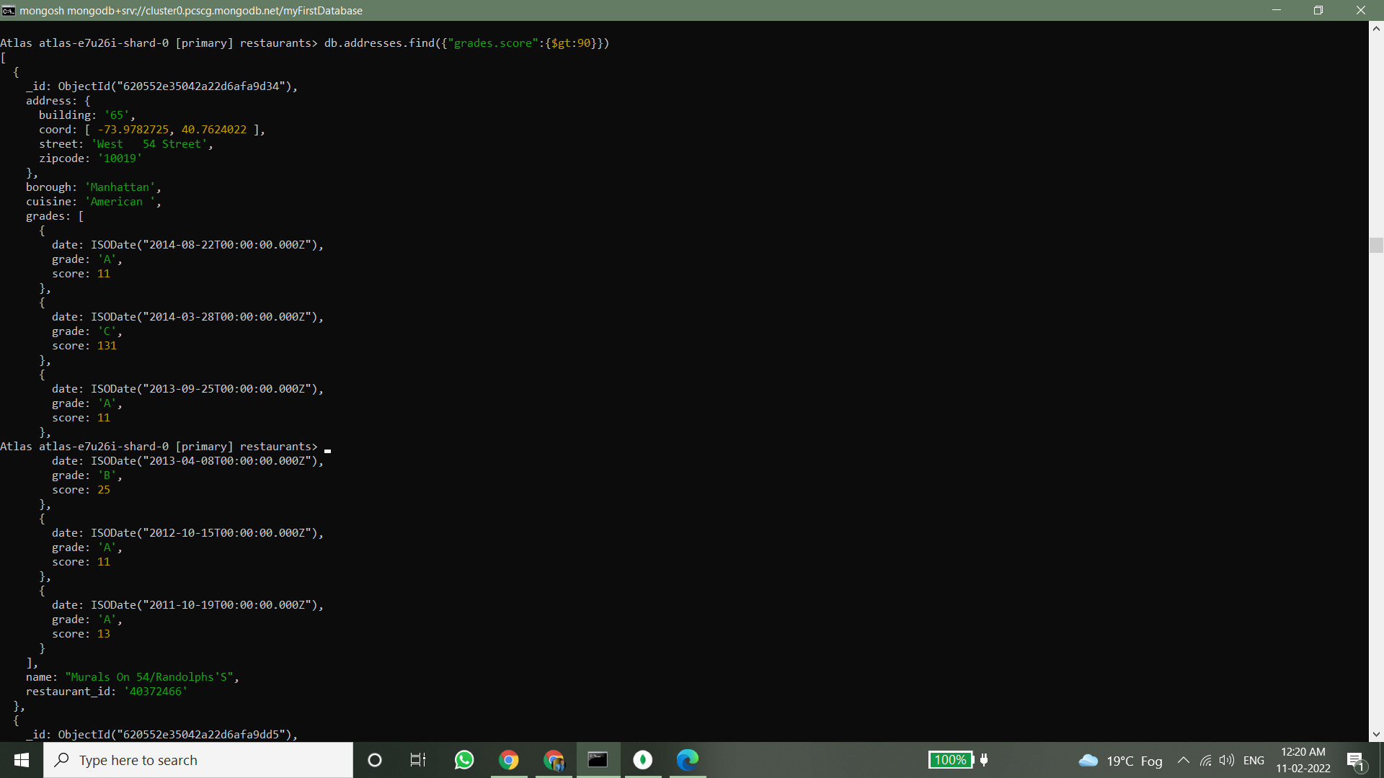

9. Write a MongoDB query to find the restaurants that achieved a score, more than 80 but less than 100. 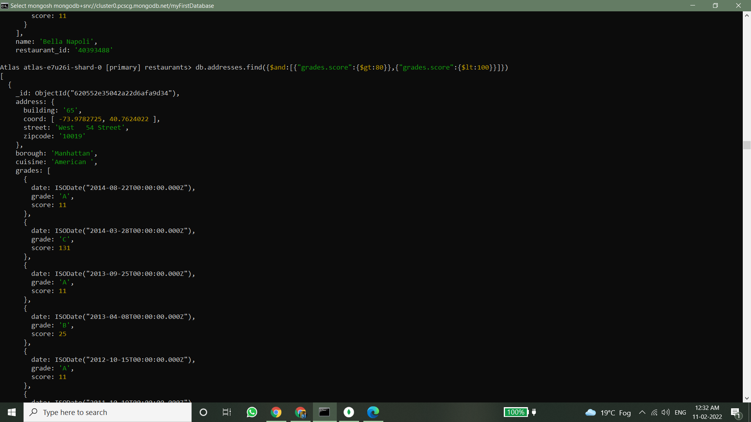

10. Write a MongoDB query to find the restaurants which locate in latitude value less than -95.754168. 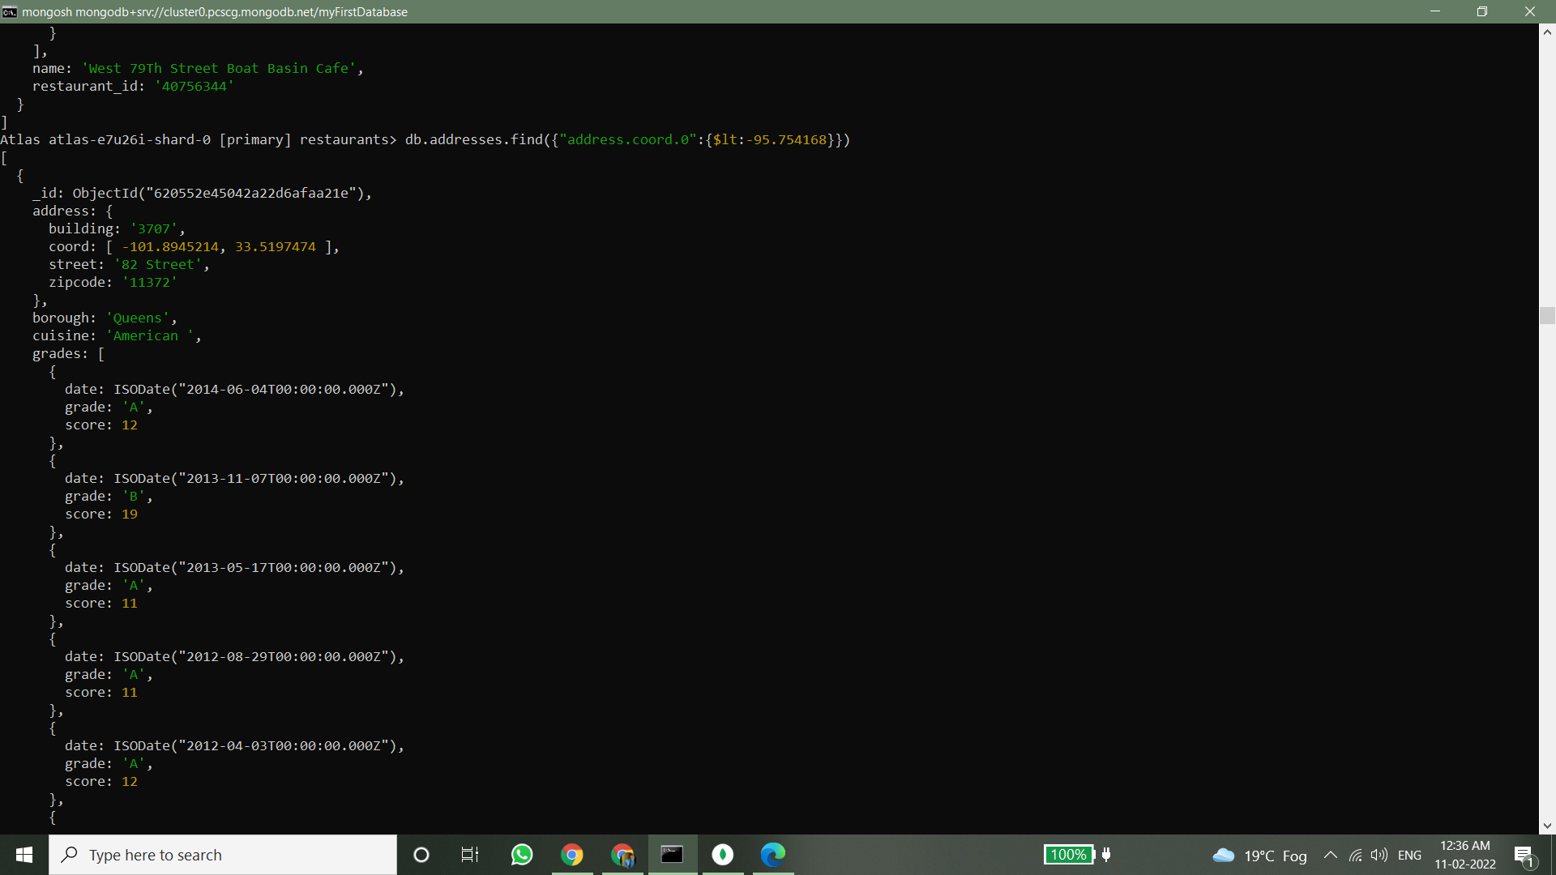

11. Write a MongoDB query to find the restaurants that do not prepare any cuisine of 'American' and their grade score more than 70 and latitude less than -65.754168.

12. Write a MongoDB query to find the restaurants which do not prepare any cuisine of 'American' and achieved a score more than 70 and located in the longitude less than -65.754168.